1) INTRODUCTION

1.1 Overview:

A health hub may offer a range of services, such as primary healthcare, mental health services, health education, disease prevention and management programs, and social services. It may also provide access to specialized care, such as dental, vision, and hearing services.

1.2 Purpose:

HealthHub is a Singaporeans' “digital healthcare companion”, providing one-stop access to their personal medical records, links to healthcare services and institutions and related information and tools so they can take control of their health.

2) PROBLEM DEFINITION & DESIGN THINKIN

A) Empathy Map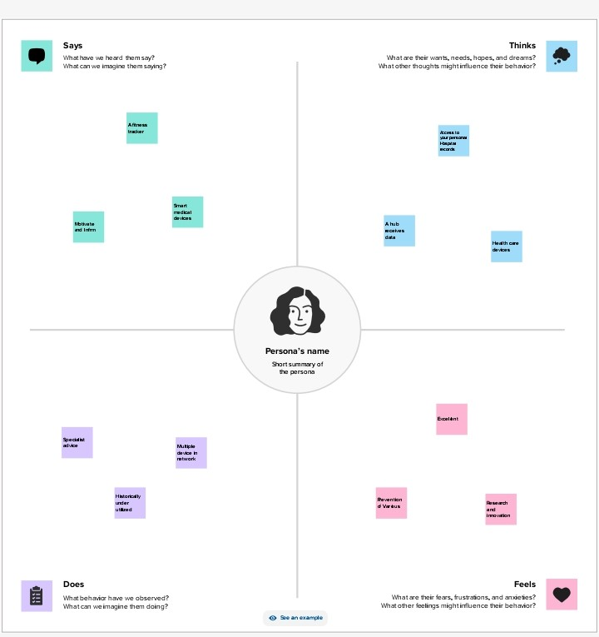G

B) Ideation & Brainstorming Map

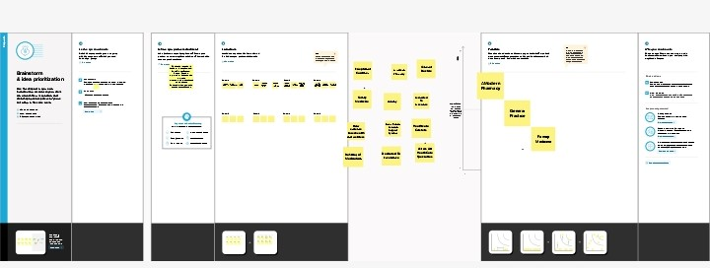

3 Result

A) Profit & Loss A/c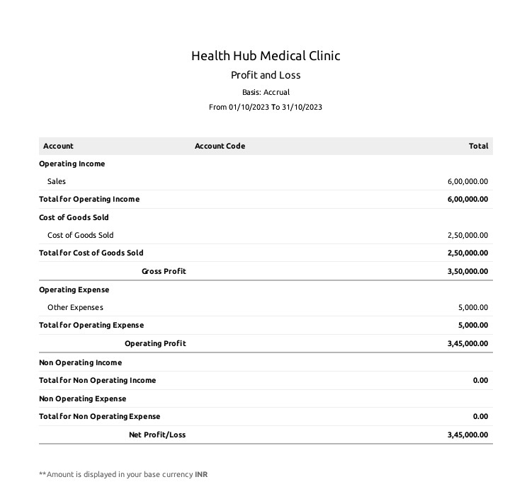

B) Balance Sheet

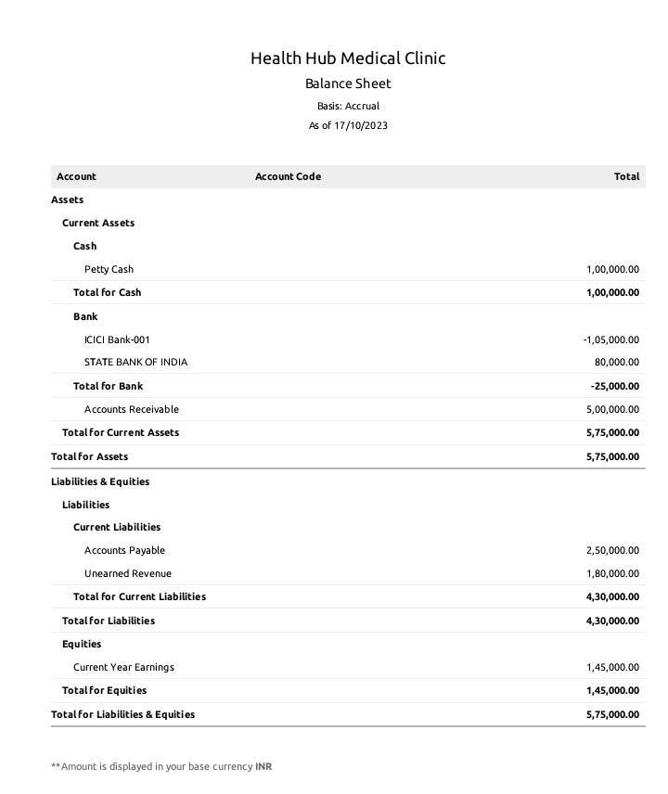4) Advantages & Disadvantages

ADVANTAGES

* It provides you access to the best medical doctors & specialists.
* SmartDoc can be used from wherever you are.
* It's extremely easy to use and is convenient.
* You save time by avoiding long queues and waiting times.
* It's continuous health management helps you monitor your health, 24/7.

DISADVANTAGES

Health insurance provides policyholders with an array of benefits such as peace of mind, access to high-quality healthcare, financial security and so on. However, it also has drawbacks, such as high premium costs, restrictive coverage options and complicated administrative requirements.

APPLICATION

Technology has the potential to significantly improve India's health infrastructure by increasing access to care, improving the quality and efficiency of care delivery, and decreasing medical errors.

CONCLUSION

Primary health care (PHC) is "essential health care" that is based on scientifically sound and socially acceptable methods and technology. This makes universal health care accessible to all individuals and families in a community.

FUTURE SCOPE

1) Traditional clinical preventive intervention

2) Innovative preventive interventions that extend care outside the

clinical setting

3) Total population or community-wide interventions